

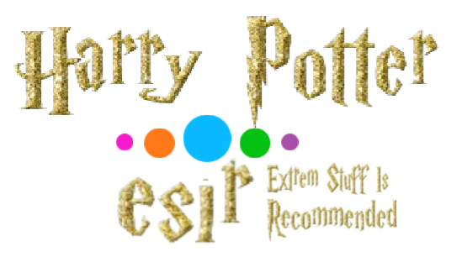

Loïc Insalaco & Robin Février & Léo Guilpain &Thomas Legris & Vincent Greco & Matthew Atkinson

Summary

Roles 2

Hagrid and Harry at the lighthouse 3

(Harry, Uncle, Hagrid, Aunt, cousin) 3

Olivander 5

(Olivander, Harry, Hagrid) 5

Track 9 ¾ 6

(Mme Weasley, Harry, George, Fred, Ginny) 6

The Sorting Hat 7

(Hermione, McGonagall, Dumbledore, Ron, Sorting hat, Harry, Fred et Georges) 7

First Lesson with McGonagall 9

(Ron, McGonagall, Harry) 9

Second Lesson with Rogue 10

(Rogue, Harry) 10

Third Lesson with Flitwick 11

(Flitwick, Hermione, Ron, Harry, Seamus) 11

Touffu and Hagrid 12

(Hagrid, Harry, Ron, Hermione) 12

Roles

|  |  |  |  |  |  |  |
| --- | --- | --- | --- | --- | --- | --- |
|  | Matthew | Robin | Vincent | Thomas | Léo | Loïc |
| Harry |  |  |  |  |  |  |
| Uncle |  |  |  |  |  |  |
| Hagrid |  |  |  |  |  |  |
| Cousin |  |  |  |  |  |  |
| Aunt |  |  |  |  |  |  |
| Olivander |  |  |  |  |  |  |
| Mrs Weasley |  |  |  |  |  |  |
| Ginny |  |  |  |  |  |  |
| George |  |  |  |  |  |  |
| Fred |  |  |  |  |  |  |
| Ron |  |  |  |  |  |  |
| Hermione |  |  |  |  |  |  |
| Snape |  |  |  |  |  |  |
| McGonagall |  |  |  |  |  |  |
| Flitwick |  |  |  |  |  |  |
| Dumbledore |  |  |  |  |  |  |
| Student |  |  |  |  |  |  |
| Sorting Hat |  |  |  |  |  |  |

Hagrid and Harry at the lighthouse

(Harry, Uncle, Hagrid, Aunt, cousin)

**Harry:** *voice-over* Today it is my birthday and also I have to go back to school

**Harry:** Please, I don’t want to go to school this year.

**Uncle:** Who’s knocking at the door?

**Hagrid:** What a miserable door…

**Uncle:** It’s a door from IKEA which has cost us a fortune!

**Hagrid:** You are joking, right? That’s the worst quality!

**Hagrid:** Ah hello Harry, euh, Do you not abused a little bit to much on the tacos, hein?

**Cousin:** I, I, I am nooot Harry…

**Harry:** I am Harry.

**Hagrid:** Of course, fortunately because if it was this guy, he would have eaten all my present… Take this!

**Harry:** Are you dyslexic?

**Hagrid:** Me too, I didn’t like to go to school…

**Hagrid:** *when he sit down* Aaaaaaaaaah!

**Hagrid:** Sorry, I have some gas right now…

**Harry:** Hum Hum…

**Harry:** So, who are you?

**Hagrid:** I am Pascal the big Brother and I’m here to take you to school.

**Harry:** No, I don’t want to…

**Hagrid:** Oh really? But do you know that you have no choice little boy?

**Harry:** Why !?

**Hagrid:** Because if not, I should bring you there by the scruff of the neck.

**Harry:** Oh really ?

**Hagrid:** Oh yeah, we don’t laugh with school.

**Harry:** I always hated classes, a real phobia!

**Harry:** I beg you, don’t bring me back… Please

**Hagrid:** I’m sorry but you have no choice, besides, I have a letter for you.

**Harry:** We are pleased to inform you that you have been accepted…

**Uncle:** No way! He will not go back to school…

**Harry:** Please save me!

**Aunt:** You’re kidding me, we are going to take this chance, you, the little Harry, who doesn’t do anything of his days except playing at the playstation sprawled on his bed for hours and hours. Oh yeah, FOOL! This time we will make you pay every lunchtime when you have not cleared the table, made the dinner and even swept on the floor.

**Harry:** Wait, you have completely go nuts!

**Hagrid:** Harry Potter!

**Hagrid:** I have heard enough!

**Uncle:** And what are you going to do?

**Hagrid:** What I am going to do, my big « pag » ?

**Harry:** *rectification* Euh PIG.

**Hagrid:** Oh yes pig sorry… don’t push me to the limit! I am not here to laugh with you. I am Pascal the big Brother, did you forget it? Now you will leave with me Harry, we have to go!

**Uncle:** No way we will do that, Harry Potter is ours!

**Hagrid:** Do you want me to release another gas? Or I can do better…

**Family :** Aaaaaaaaaaaaaaaaaah!!!!

**Hagrid:** So what do you want to do, do you prefer to work or do you prefer to stay here with them?

**Harry:** Work!

**Hagrid:** So it’s time to go!

**Hagrid:** It’s a real shitty door…

Olivander

(Olivander, Harry, Hagrid)

**Olivander:** Heyyyyyy come on my friend i have so many things for you

I know exactly what you want.... pink wand are the best but you don't seems to be that kind of student.

- Ah !

- 5000 Gallions !

- what ! you don't want it ?

dumb kid....

4000...Gallions

WTF ! it was my grandMother ashes inside !!

I'll con that kid

Maybe that !

**Olivander:**  I need...To stop smoking

**Harry:** Sorry but  i don't like this wand

**Olivander:** I don't understand pure plastic, chicken leg inside is the best wand you can have.

Real wand with real wood and real phoenix fether are for real wizard who know that shaking the wand without telling a spell is useless and i don't want to sell a wand to you and your stupid tatoo on your forehead

**Harry:** But it's not fair

**Olivander:** what can i say....., the wand chooses  the wizard mr Potter. But it is not a suprise that this wand chooses you....But i think it is clear that we can't expect great things from you

But don't think you can have a discount..5000 Gallions.. no 6000 ...Yeah pay it !

**Hagrid:** Harry ! I found our dinner for tonight !

Track 9 ¾

(Mme Weasley, Harry, George, Fred, Ginny)

**Mrs. Weasley:** It's still a mess after all these years, the INSA students are everywhere.

**Harry:** INSA ?

**Mrs. Weasley:** Come on. Platform 9¾ this way! Percy, you're the dumbest, you start..

**Mrs. Weasley:** Fred, you are next.

**George:** He's not Fred, I am!

**Fred:** Honestly, you think you're smart.

**Mrs. Weasley:**  Hope you ‘re gonna hit the wall !

**Fred:** I'm only joking. I am Fred.

**Harry:** Excuse me! C-could you tell me if ?

**Mrs. Weasley:**  If I'm your mother? No, I'm sorry, my boy. Same for Ron, he's adopted. Anyway, to get to Insa, you follow the 3 redheads and run into the wall. Don't be nervous, if the redheads have succeeded, you can do it.

**Ginny:** Good luck.

The Sorting Hat

(Hermione, McGonagall, Dumbledore, Ron, Sorting hat, Harry, Fred et Georges)

**Hermione:** You think this is a beautiful night but it’s raining cats and dogs in this country. It’s just illusion, false ceiling, Ikea again, but remember, in Britain, it’s raining just on the idiots.

**McGonagall:** Stay here before we begin. First, listen the grandpa who takes himself for the headmaster.

**Dumbledore:** This year, some points of the regulation have changed. As measure of respect, all jokes against mothers or sisters will be forbidden. Don’t joke with that. Otherwise, WEI for this year will be manage by Mr Rusard and his watch cat. He will sell mild drugs for the good of everyone. Do not abuse of this, it can create some confusion sometimes.

**McGonagall:** When I call you by your name, you will come forth and I will set the hat on your head. Hermione, here.

**Hermione:** She is getting on my nerves.

**Ron:** Both of them are getting on me.

**Sorting Hat:** Oh, boring.. but brilliant. SI !

**McGonagall:** Draco Malfoy

**Sorting Hat:** Fired !

**Ron:** Sorting hat do not like his peroxidised blond dye.

**McGonagall:** Susan Boyle.

**Harry:** Aïe

**Ron:** What’s happening to you?

**Harry:** I’ve got a spot on my face, hurts me to much.

**Sorting Hat:** Let's see...I know...Hufflepuff!

**McGonagall:** Ronald Weasley.

**Sorting Hat:** Oh, redhead again. Then, like your brothers, SI !

**McGonagall:** Harry Potter.

**Sorting Hat:** You will bother us for 8 movies. I warn you, don’t charm your redhead friend’s sister. So get back to your selection, do you enjoy work? Because in IOT it’s cool in point of view of hours in class.

**Harry:** Not IOT. Not IOT.

**Sorting Hat:** Not IOT, eh? Are you sure? You don’t like holiday? You don’t like 4 days weekends? It’s all here in your head. So go in Materiaux, you will learn periodic table and other interessant things.

**Harry:** Neither Matériaux...nor IOT please bro.

**Sorting Hat:** I am not your friend, go in.. mhh.. ... SI!!

**Fred and George:** We got Potter! We got Potter!

**McGonagall:** Please, Grandpa would like to say something

**Dumbledore:**  McDo for everyone.. unlimited.

First Lesson with McGonagall

(Ron, McGonagall, Harry)

**Ron:** Piouf, we're almost on time. Look Harry, the cat is way prettier than the old McGonagall

**Ron:** Whouah !! You are really beautiful and talented hum hum

**McGonagall:** Thanks for kidding me redhead! I can not say as much of you between one who looks dumb and the other who is sloppy. Why are you so late ?

**Harry:** Ron was giving me a massage

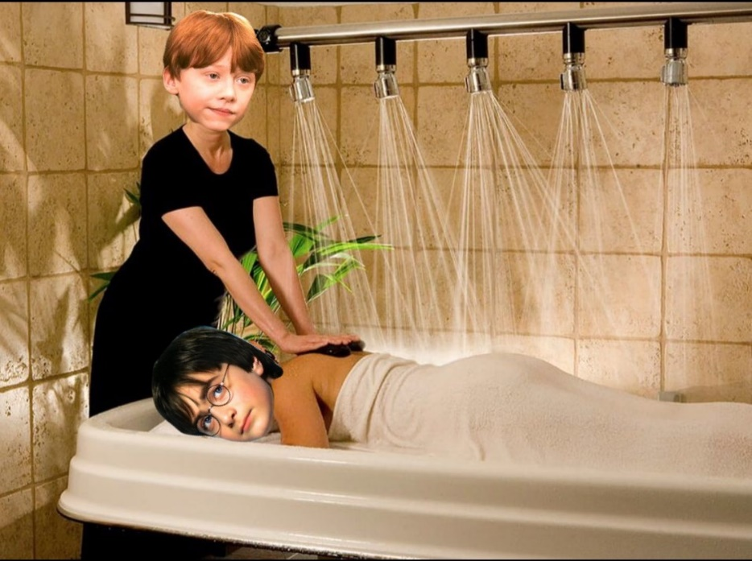

**McGonagall:** A massage? don’t take me for a fool ! Alright, sit down and be quite.

Second Lesson with Rogue

(Rogue, Harry)

**Snape:** Hello, I'm the beautiful and funny Professor Snape, I teach you the philosophy of the engineer. I have the feeling that this year we have a good promotion because you seem crazy, and it is an asset in philosophy.

2 rules have to be follow in my class:

1- Close your mouth when I speak

2- Always look at me when I speak to admire my beauty

Mr. Potter, the chosen one. Let's see if you're as stupid as they say you are. I have a question for you: What do we get by mixing reality and imagination?

**Harry:** …

**Snape:** You know nothing.. But do you know who your father is?

**Harry:** I don’t know sir

**Snape:** What is the best school between INSA and ESIR?

**Harry:** I don’t know sir

**Snape:** Too bad. Obviously, celebrity is not everything ..., Mr. Potter?

**Harry:** Clearly, the nerdy on my left knows. How sad it is not to ask her.

**Snape:** Silence, and drop your fucking silly hand! To answer the questions, Potter, the difference between INSA and ESIR, is the name:

INSA: Institute Needless Smart Arse (stupid anyone)

ESIR: Extrem Stuff Is Recommended

And for the last question, I'm your father Harry Potter, yes your mother is a drag, she was cheating on your father with me. And it's not the only one if you know what I mean.

Third Lesson with Flitwick

(Flitwick, Hermione, Ron, Harry, Seamus)

**Flitwick:** Then we are going to speak about a delicate subject. Have somebody in this room done an internship in the company of its dreams?

**Flitwick:** Yes of course, still a who passed under the desk.

For others, I am going to learn you to make levitate a feather, that will add unstoppable skill to your resume.

For it pronounce the sentence: "Alcohol is water".

**Ron:** Beer which foams amasses the crowd.

**Hermione:** Stop ! Stop ! Stop ! It is not that! It’s beer which foams amasses the red-haired persons.

**Ron:** You do it then if you're so clever. Go on, go on.

**Hermione:** Beer which foams amasses the red-haired persons

**Flitwick:** Oh, well done! See here, everyone! Ms. Granger's done it! Oh, splendid!

**Seamus** : Alcohol kills.

**Flitwick:** Well done, dear.

**Flitwick:** Whooaaa! Ooh

**Harry:** Never criticize alcohol Satanas !

Touffu and Hagrid

(Hagrid, Harry, Ron, Hermione)

**Hagrid:** Bullshit, why would the students at INSA be inferior to you?

**Harry:** You don't know? It has been like that for years. Besides, they're ugly.

**Hagrid:** Who told you they were ugly?

**Ron:** Really ?

**Hermione:** You really don't know Pascal?

**Hagrid:** Well, I admit I know, everyone's talking about it around me. The INSA students are trying to steal your secret. but...

**Harry:** Yes ?

**Hagrid:** Shouldn’t have said that. No more questions! Don’t ask any more questions.

**Harry:** But Pascal, you have to tell us, they can't find it.

**Hagrid:** I can't, Dumbledore trusts me.

**Hermione:** Trust me or not, you have to tell us. I've read a lot about the people at the INSA and they're not very smart, so it shouldn't get out of hand.

**Harry:** Exactly.

**Hagrid:** Now, you listen to me, all three of you. You’re meddling in things that ought not to be meddled in. It’s dangerous. What that dog guarding is between Dumbledore and Mr Wolinski.

**Harry:** Mr Wolinski ?

**Hagrid:** I shouldn’t have said that. I shouldn’t have said that.

**Harry:** Mr Wolinski ? Why Mr Wolinski ?

**Hermione:** I don’t know.